**HUMAN IN THE LOOP**

**https://24x7offshoring.com/**

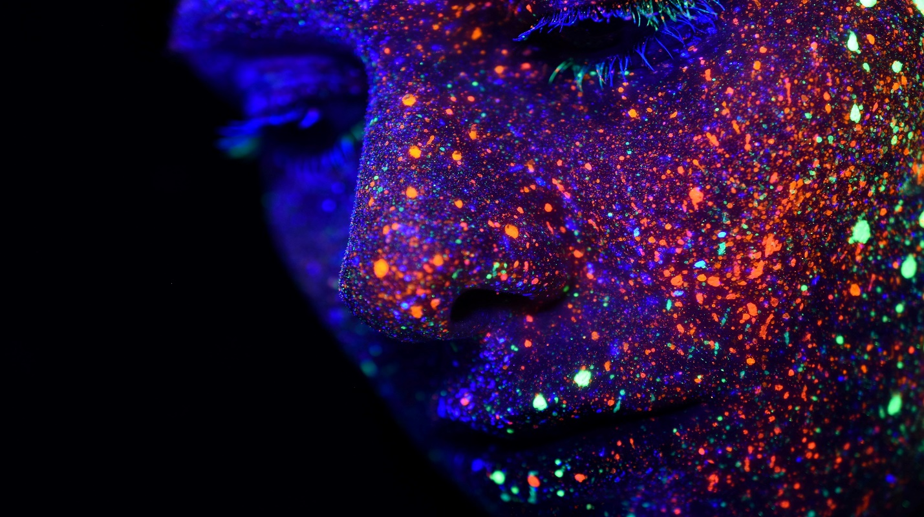 [**http://24x7outsourcing.com/**](http://24x7outsourcing.com/)

**What is Human-tuned in Machine Learning?**

Human-on top of it (HITL) is a part of man-made brainpower that use both human and machine knowledge to make AI models. In a conventional human-on top of it approach, individuals are associated with an idealistic circle where they train, tune, and test a specific calculation.

**By and large, it works this way:**

To begin with, people mark information. This gives a model superior grade (and high amounts of) preparing information. An AI calculation figures out how to settle on choices from this information.

Then, people tune the model. This can h24x7offshoring.com in a few distinct manners, however regularly, people will score information to represent overfitting, to show a classifier edge cases, or new classifications in the model's domain.

Ultimately, individuals can test and approve a model by scoring its yields, particularly in places where a calculation is unconfident about a judgment or excessively certain about an off base choice.

Presently, it's essential to take note of that every one of these activities includes a consistent input circle.

Human-tuned in AI implies taking every one of these preparation, tuning, and testing errands and taking care of them back into the calculation so it gets more astute, more certain, and more exact.

This can be particularly successful when the model chooses what it needs to realize next–known as dynamic learning–and you send that information to human annotators for preparing.

Human-insider savvy is a methodology that we at 24x7offshoring.com have advocated for quite a long time.

We've seen it help improve models of each stripe, regardless of whether they're text classifiers, PC vision calculations, or search and data recovery models.

We can make tremendous amounts of exceptionally exact preparing information for your special use case, at that point tune your model with human understanding, and test it to settle on sure its choices are precise and significant.

In the event that you'd prefer to find out additional, kindly don't stop for a second to connect.

**Human-tuned in FAQs**

**How would you consolidate individuals and machines to make AI?**

The human-on the up and up approach consolidates the best of human knowledge with the best of machine insight.

Machines are extraordinary at settling on keen choices from tremendous datasets, though individuals are vastly improved at settling on choices with less information.

**For model, individuals are incredible at taking a gander at an unpredictable picture and selecting discrete elements:**

"This is a light post" or "that is a feline, yet you can just see its tail."

This is the specific kind of data a machine needs to comprehend what a light post or a feline resembles.

Truth be told, a machine needs to see many light posts and felines from various points, halfway blocked, in various tones, and so forth to comprehend what one resembles.

A powerful dataset of these named pictures (for example human knowledge) shows a machine to see those things (for example machine insight).

Also, sooner or later, with enough information and enough tuning, those machine calculations can see and comprehend pictures rapidly and unbelievably precise without the requirement for individuals to continually mention to it what precisely a feline (or a light post) resembles.

**HUMAN IN THE LOOP**

**https://24x7offshoring.com/**

**http://24x7outsourcing.com/**